Test Plan – AcademyBugs Website

Project Name : Manual and Automation for AcademyBugs Website
URL: https://academybugs.com
Executed By: Amritha V J

Introduction
This Test Summary Report provides a consolidated overview of the testing activities carried out on the Academy application. The report is derived from executed test cases and the analyzed defect report. Testing was performed using both manual and automation approaches to ensure functional correctness, stability, and usability of the application before release.

Objective
The primary objectives of testing were:
- To validate core application functionalities against requirements
- To identify functional, UI, and navigation-related defects
- To verify defect fixes through re-testing
- To ensure system stability through regression testing
- To determine release readiness of the application

Scope (In-scope / Out-of-scope)
- In scope
  - Dashboard navigation and link validation
  - Bug examples (Social share, Send button, Video player, Search, Sign-up, Login, Booking)
  - Bug type pages (Functional, Visual, Performance, Crash, Content)
  - Finding bugs features (Cart, Pagination, Checkout, Coupons, Payment)
  - Report bugs module (Dropdowns, Radio buttons, Drag-and-drop)
  - Sign Up / Login / Logout
  - Footer section links and icons
  - Responsiveness
  - Cross browser testing
- Out of scope
  - Backend database validation
  - Load/stress performance testing
    - Payment gateway actual transactions

Test Environment
- Browser: Chrome, Firefox, Edge
- OS: Windows 11, Android
- Tools:
  - Test case management : Excel
  - Bug tracking : Excel sheet
  - Automation : Selenium webdriver
  - Framework : TestNG, POM, Maven

Test Deliverables
- Test Plan Document
- Test Cases (Manual + Automated)
- Test Execution Report
- Defect Log
- Automation Scripts Repository
- Test Summary Report

Testing Approach
- Testing type used
  - Functional Testing
  - UI/UX Testing
  - Smoke testing
  - Regression Testing
  - Negative Testing
  - Cross-browser Testing (Chrome, Firefox, Edge)
  - Responsiveness Testing
  - Exploratory Testing
- Manual testing
  - Exploratory testing for UI/UX and responsiveness
  - Form validation and error handling
  - Redirection and link testing
  - User flow validation (Sign-up -> Login -> Logout)
- Automation testing
  - Use Selenium WebDriver with Java
  - Automate form submissions, link clicks, and validation checks
  - Use TestNG/JUnit for test structuring

Defect Summary Table
Sl No | Severity | No.of defects | Status
1 | High | 11 | Open
2 | Medium | 78 | Open
3 | Low | 6 | Open

Test metrics
Sl No | Item | Count
1 | Total Test Cases Executed | 237
2 | Test Cases Passed | 142
3 | Test Cases Failed | 95
4 | Test Cases Blocked | 1
5 | Defects Reported | 95
6 | Defects closed | 0

Defect Analysis Summary

Severity-Based Analysis
- High severity defects impacted key functional behavior and were prioritized for immediate fixes.
- Medium severity defects affected usability and non-critical workflows.
- Low severity defects were mainly cosmetic or minor UI issues.

Risks and Limitations
- Testing was limited to defined scope and test data.
- Areas not covered (performance, security) may require future validation.
- Any new enhancements may require additional regression testing.

Conclusions and Recommendations
The current build is not stable for release due to the presence of critical defects in the authentication and checkout modules. These defects directly impact core user flows and system security, making the application unsuitable for production at this stage.
- Resolve identified security-related defects in the authentication module (DF013, DF016, DF018).
- Implement and validate mandatory field and payment validations in the checkout process (DF020–DF026).
- Perform re-testing of all fixed defects followed by full regression testing on critical user scenarios to ensure system stability.

HTML Reports
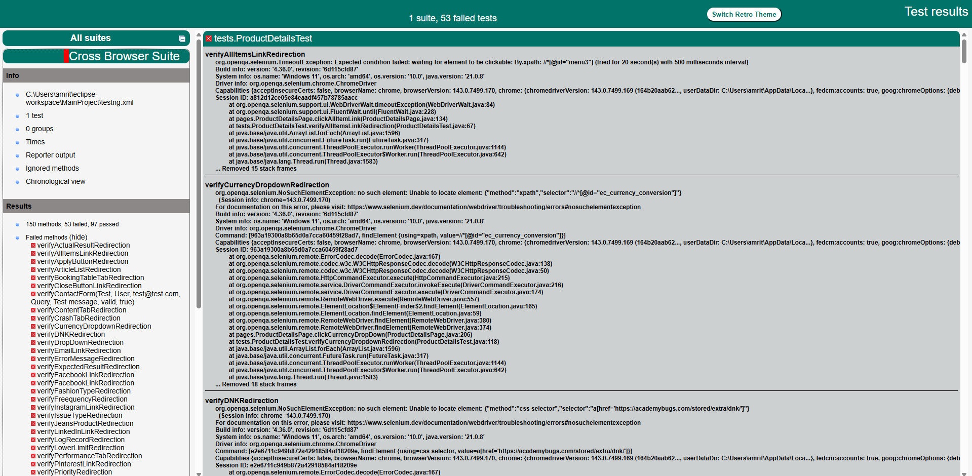

Emailable Reports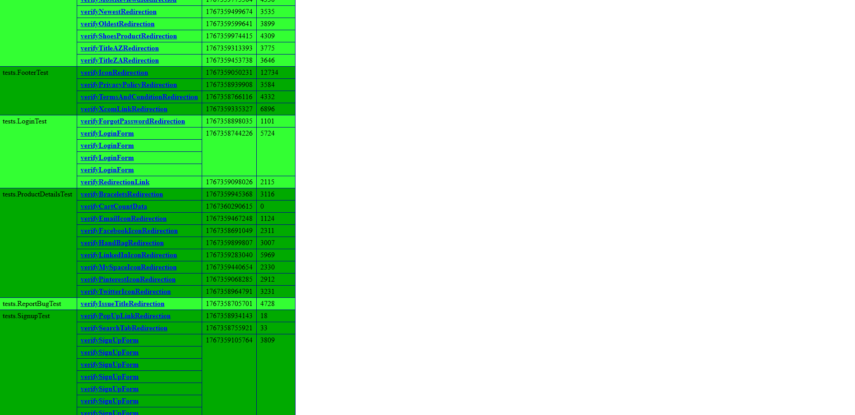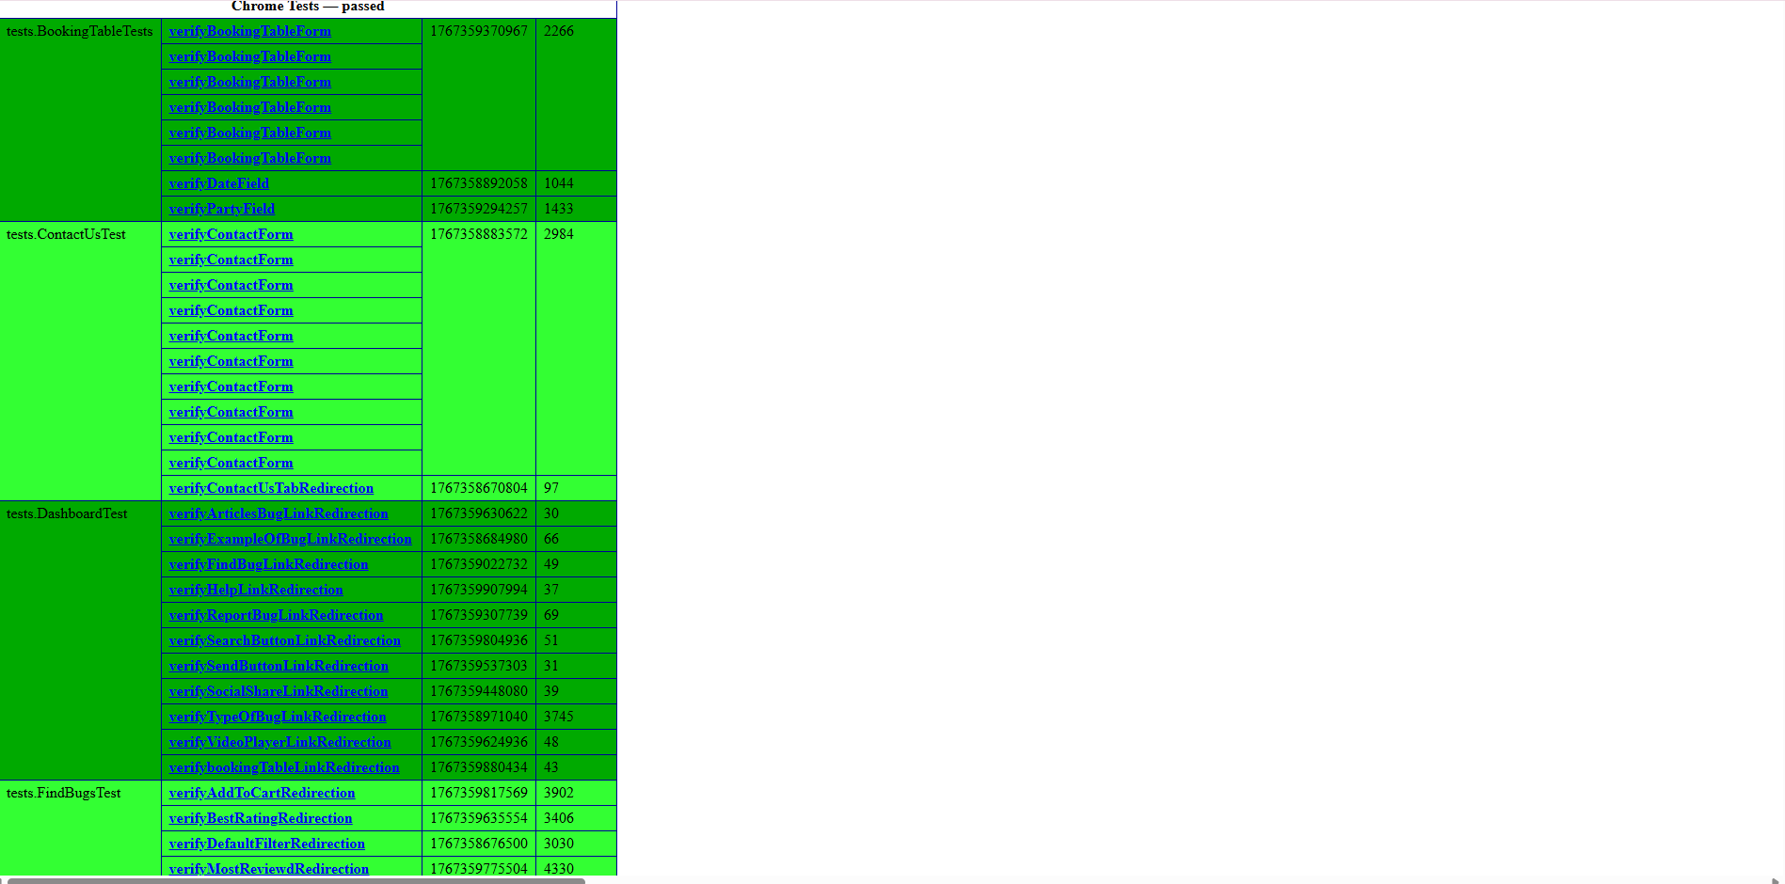
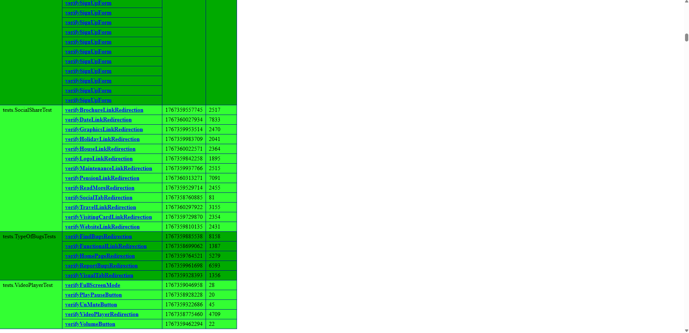
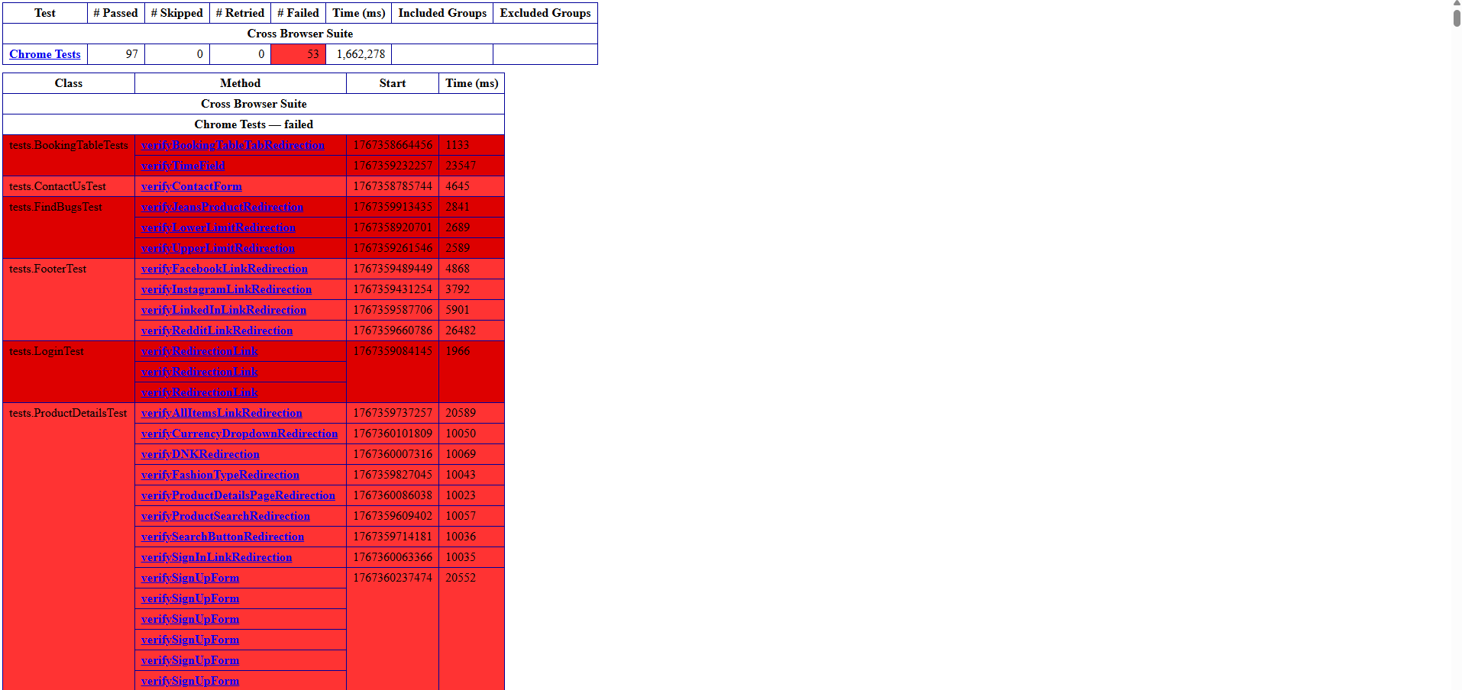
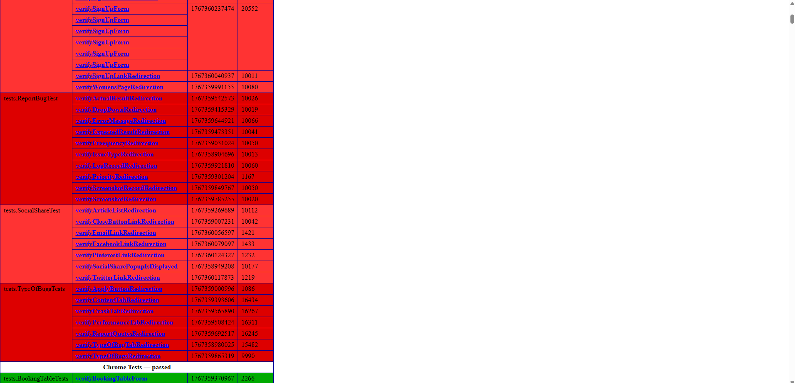
Notes:
Test Plan
Test case Document
Defect Report
Feature Listing
Github link

